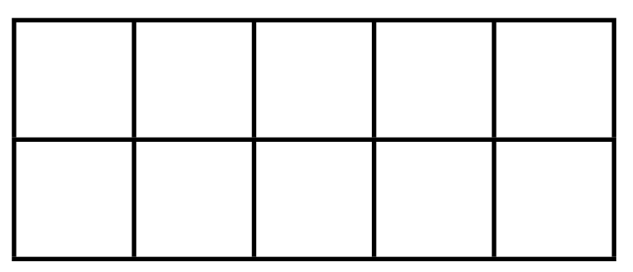10

 and

___

more

is ____