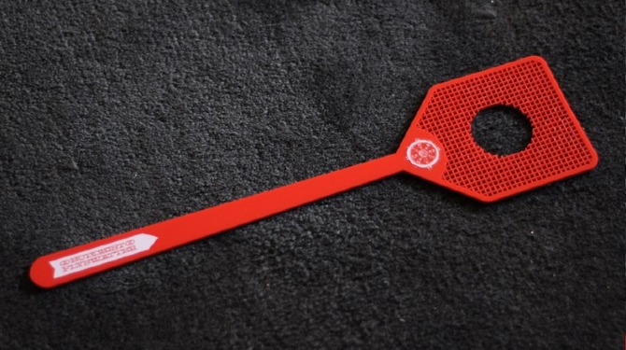
Roll and SLAP
4 2 1 5 0 1 3 4
Roll and SLAP
5 9 7

10 8 6
Roll and SLAP
14 12 11

10 15 13
Roll and SLAP
17 16 19

15 18 20

