1 More Towers
2 | 3 | 4 | 5 | 6 | 7

BUILD WHAT YOU ROLLED then add 1
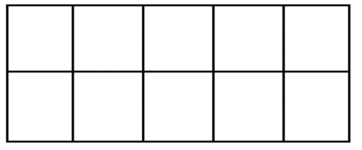
Directions:
- Roll the dice
- Build the quantity on the ten frame
- Add one more
- Place a cube on the number you now have
- Continue until the teacher says stop!
- Which number did you get the most?

