I rolled a | How many more to get to 10?
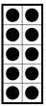
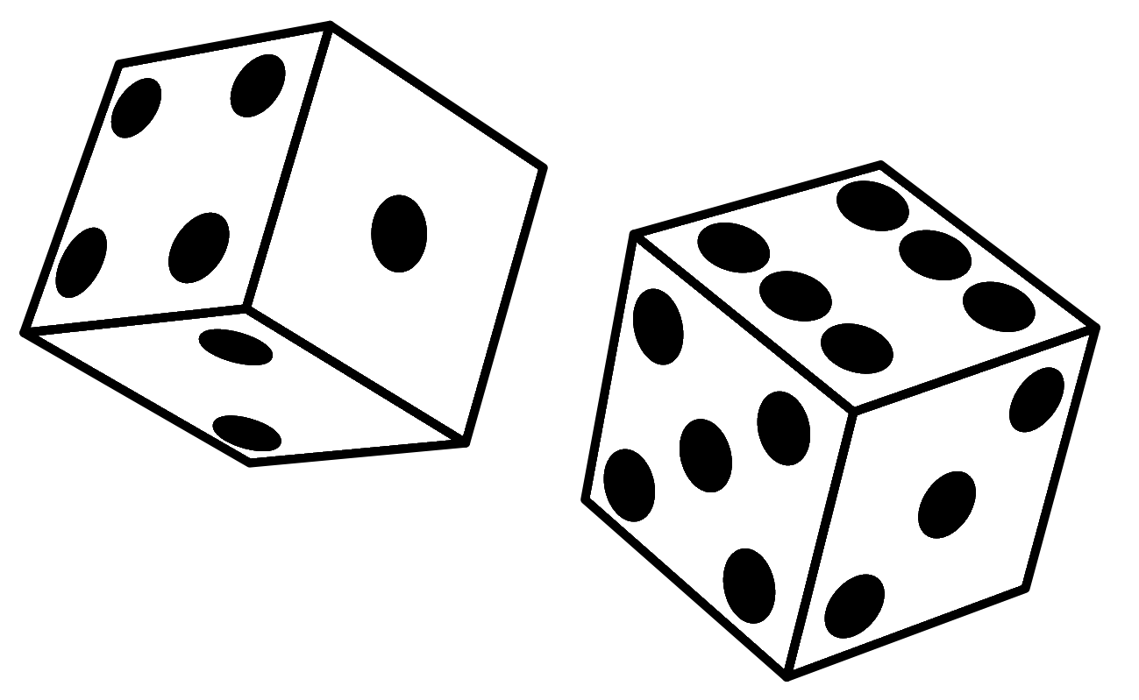
Roll and Build
10 MAKING TEN!

