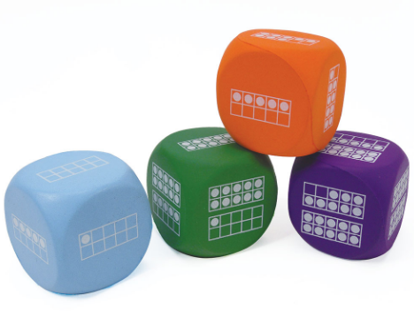
Roll/Build: How many more to 20?
I rolled a | How many more to get to 20?

