Name__________________ Grade: _____ Date:_______________________

Math Around Us

The purpose of this assessment is to inquiry into the student’s general awareness of number, space and time.

Suggested prompts: Tell me what you’re thinking. Think about it again.

When (what month) does school begin/end?
What month is Hallowe’en/Christmas in?
(ESL students may not be familiar with these celebrations so you could ask about ones like Diwali.)
When is your birthday?
What year were you born?
How old will you be when you’re in Grade ____?
(Add 2 years to present grade)
How much does a chocolate bar cost?
(or chose something that the student will be familiar with)
When do you usually watch TV? About how long is the show you watch?
What time does school start?
What time is lunch?
About how long is recess?
About how many hours are we in school?
Do you know any of your friends’ or family members’ phone numbers? (other than the child’s own)
What is your address?

Assessment of Mathematical Awareness: ongoing throughout the assessment

NOT SOMETIMES ALWAYS
DISPOSITIONS/HABITS OF MIND: EVIDENT EVIDENT EVIDENT

- Tries to make sense
- Is confident, willing to take risks
- Perseveres
- Tries to find more than one strategy

NOT SOMETIMES ALWAYS
LEARNING CHARACTERISTICS: EVIDENT EVIDENT EVIDENT

- Ability to organize (materials, thoughts, work…)
- Ability to articulate thinking and procedures verbally
- Ability to model or to represent thinking on paper (using pictures, numbers, or words)
- Ability to use mathematical language

Name_____________________ Grade: ____ Date:______________

Up and Through the Hundreds

- Write the numbers to the end of the boxes.
Begin at 91 and count by ONES to the end of the boxes.

91 | 92 | 93

- Write the numbers to the end of the boxes.
Begin at 421 and count by TENS to the end of the boxes.

421 | 431 | 441

- Write the numbers to the end of the boxes.
Begin at 205 and count by HUNDREDS to the end of the boxes.

205 | 305 | 405

Name_____________________ Grade: ____ Date:______________

Read and Write Numbers Through Hundreds

Write the numbers the teacher says. Here is an example:
If the teacher says twenty-two, you write 22.

- ________ D. ________

- ________ E. ________

- ________ F. ________

Read these numbers aloud:

G. 65

H. 113

- 307

- 780

- 982

- 1005
Compare and Order

SET A: Cut out each of the following numbers. Order them from smallest to greatest and record them below:

_______ _______ _______ _______ _______ _______
36 | 403
125 | 156
74 | 18
Smallest Greatest
Compare and Order

SET B: Cut out each of the following numbers. Order them from smallest to greatest and record them below:

_______ _______ _______ _______ _______ _______
43 | 909
652 | 325
110 | 789
Smallest Greatest

Name_____________________ Grade: ____ Date:______________

Friendly Numbers

Solve the following question using two different strategies:

- 8 + 7 =

Explain your strategies using words, pictures, and/or numbers and symbols.
One way I solved the question | A second way I solved the question

- 12 - 7 =
Explain your strategies using words, pictures, and/or numbers and symbols.
One way I solved the question | A second way I solved the question
Name_____________________ Grade: ____ Date:______________

Addition: How Did You Do It?

26 + 37 =  My estimate is ________  Show your thinking below! | 126 + 237 =  My estimate is ________  Show your thinking below!

Name_____________________ Grade: ____ Date:______________

Subtraction: How Did You Do It?

62 - 23 =  My estimate is ________  Show your thinking below! | 562 - 423 =  My estimate is ________  Show your thinking below!

Name_____________________ Grade: ____ Date:______________

Missing Addends Task

Solve and explain your strategies.
____ + 7 = 16 | 9 + 3 = _____
9 + ____ = 15 | 8 + 2 = 5 + ____

Name_____________________ Grade: ____ Date:______________
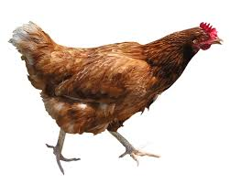
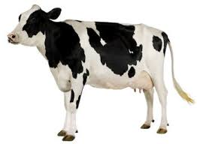
Barnyard Legs

I counted 36 legs in the barnyard.

Some belonged to cows and some belonged to chickens. How many cows and chickens might have been in the barnyard?

Show different ways and explain your thinking.

Name_____________________ Grade: ____ Date:______________

How Many Do You See In All? How Do You See Them?
How would you express this as a multiplication equation?

How Many Do You See? How Do You See Them?
How would you express this as a multiplication equation?
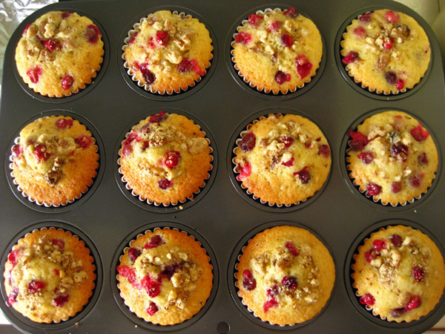

Name_____________________ Grade: ____ Date:______________

Shake and Spill

Take 12 two-sided counters in your hand. Shake and spill them onto your workspace.

Record the number of red and yellow.

What fraction of the set is red?

What fraction of the set is yellow?

Name_____________________ Grade: ____ Date:______________

Mystery Fractions

Each of these number lines have a mystery fraction shown with a ?

What is the mystery fraction? How do you know?

What else do you notice?

0 1

0 1

0 1
5
10

Name_____________________ Grade: ____ Date:______________

Which One (Mass)

What unit would you use to measure the following items?

A regular sized chocolate bar could be measured using _________

The weight of a teenager could be measured using

________

Name_____________________ Grade: ____ Date:______________

Which One (Capacity)

What unit would you use to measure the following items?
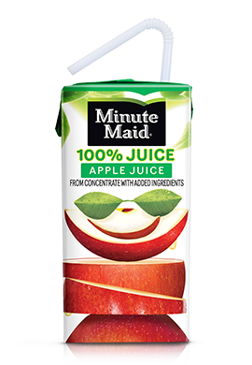

A juice box could be measured using ______

A milk jug could be measured using __________

Name_____________________ Grade: ____ Date:______________

Which One (Linear)

What unit would you use to measure the following items?

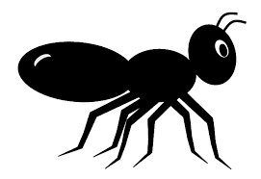

An ant could be measured using ______
A pencil could be measured using _______
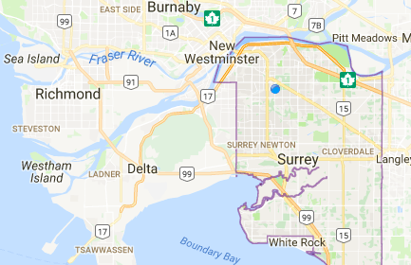

The distance it would take to drive from Surrey to Richmond or Vancouver could be measured using __________

