Bunny Marshmallows

Big Idea: Numbers to 20 represent quantities that can be decomposed into smaller parts; Addition and subtraction with numbers can be modelled concretely, pictorially, and symbolically to develop computational fluency.

Curricular Competencies:
- use reasoning to explore and make connections
- estimating reasonably
- developing mental math strategies and abilities to make sense of quantities
- visualizing to explore mathematical concepts
- model mathematics in contextualized experiences and explore the utility of mathematics as a tool for solving real-life problems
- develop, demonstrate and apply mathematical understanding through play, inquiry and problem solving.

Content: number concepts to 20; addition and subtraction to 20

ACT ONE:

What did you notice? | What do you wonder?

FOCUS QUESTION:

How many marshmallow bunnies are there in all?

Estimating:

A too low estimate: | A too high estimate:

ACT TWO:

What else do you need to know to answer the question? What information would you like to have?
e.g., How many of each different colour are there?

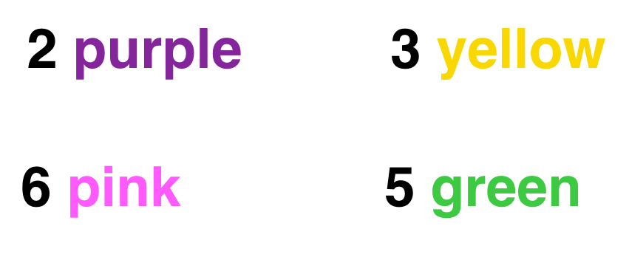

Provide students with materials they can use to model the problem. These could include:
- mini ten-frames (e.g., paper, egg cartons)
- unifix cubes (be sure not to provide all of the colours above)
- counters all the same colour (e.g., pebbles, pompoms)
- numbers (e.g., wooden, plastic, dice)
- number lines to twenty
- mini-clipboards with paper and pencils
Guiding questions during exploration time:
- How are students engaging in the problem solving? Is the student using an appropriate model/strategy for the actual situation?
  - Do they build a model to represent the marshmallows? Can they think abstractly and use different coloured or all the same colour counters to represent the marshmallows?
  - Do they use “tools” to assist them (e.g., ten frames, number lines)
  - Do they draw pictures?
  - Can they represent their concrete models pictorially?
  - Do they use labels to help communicate ideas?
  - Do they use numbers and symbols? Can they use number and symbols in connection their models?
  - Are they able to orally explain their thinking?

What STRATEGIES are being used?
Make note of who uses which strategy and take pictures or video so that these can be shared with the class as a whole.
  - Who counts all?
    - Do students have one-to-one correspondence? If they make a mistake do they catch themselves and self-correct?
  - Who counts on?
    - Are students counting on from the largest quantity?
  - Who makes ten?
    - Are students using ten frames to help them to organize the materials? If they use ten frames, do they explain how many they have stating “I have ten and six more”
    - If writing equations, do they decompose numbers and recompose to make ten?
  - Who adds in chunks?
    - Was there a method to how they added? Did they start with the largest number? Or add to get to a landmark/friendly number?
  - Who uses a doubles/near doubles strategy?
    - Did the student use concrete materials to see or create doubles?
    - Did they decompose and recompose numbers?

ACT THREE:

Gather the students and do a gallery walk around the classroom and/or share photos and videos taken via the projector with the class. Ask students to orally explain the strategies they used. Highlight, compare and connect the strategies students used.

Sharing
- Build a class anchor chart with the different strategies students used.

REVEAL the answer!
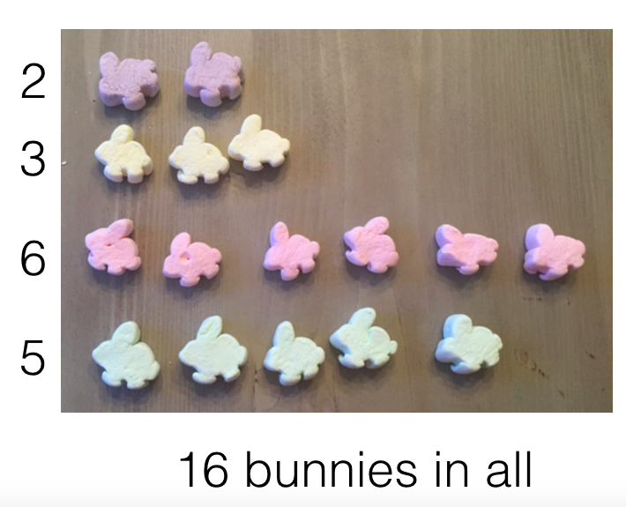

Summarize the learning:

Self-Reflection:
Strengths: What worked (What strategies did you use to work toward a solution)?
Stretches: What was difficult?
Next steps: What would you do differently next time? Was anyone inspired by someone else’s strategy?

Moving Forward:
Continue to explore different combinations of quantities to 20.

